HO CHI MINH UNIVERSITY OF TECHNOLOGY

**HO CHI MINH UNIVERSITY OF TECHNOLOGY**

Faculty of Computer Science and Engineering

------------------------



Computer Networks

Report for lab 6

Lecturer: Nguyễn Mạnh Thìn

Student name: Đặng Trần Khánh-1852037

***1/ What is the 48-bit Ethernet address of your computer?***

Answer: The 48-bit Ethernet address of my computer is 70:66:55:5b:72:7f

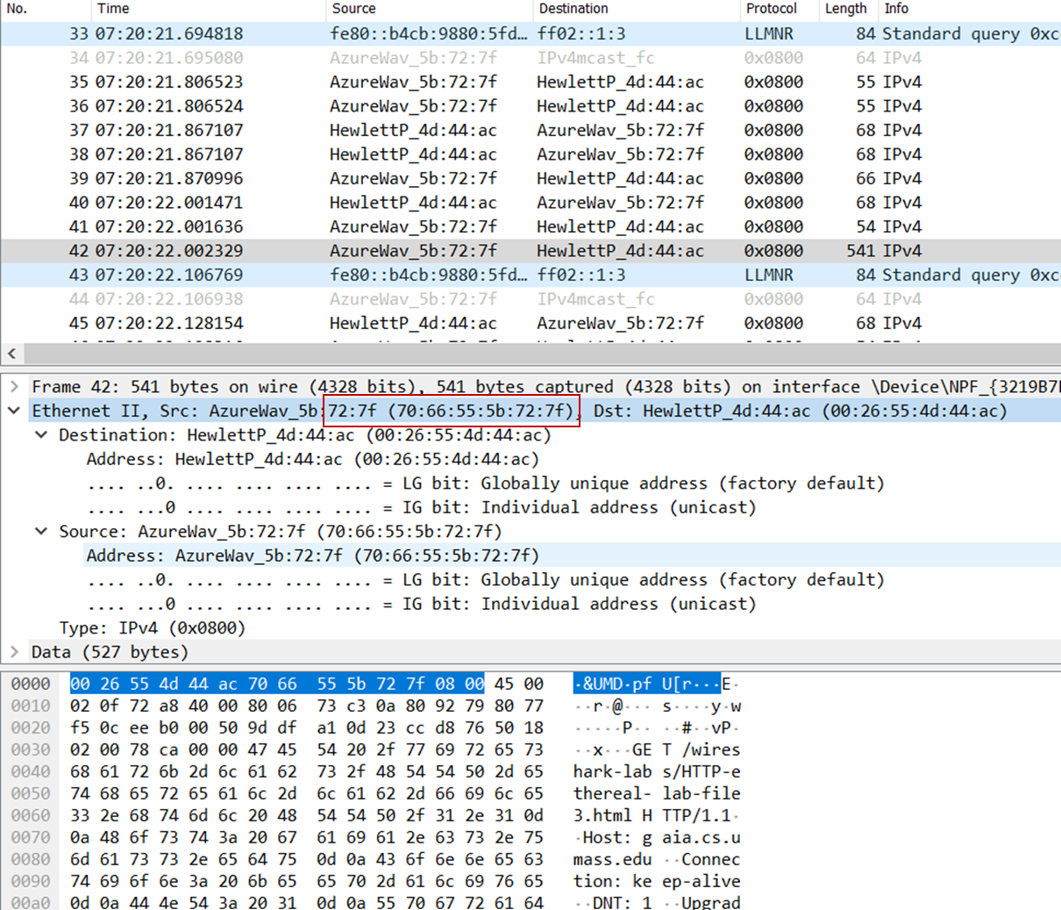

***2/ What is the 48-bit destination address in the Ethernet frame? Is this the Ethernet address of*** ***gaia.cs.umass.edu? What device has this as its Ethernet address?***

Answer: The 48-bit destination address in the Ethernet frame is 00:26:55:4d:44:ac. This is not the address of gaia.cs.umass.edu. This is the address of the router that my computer has to go through in order to reach the destination.

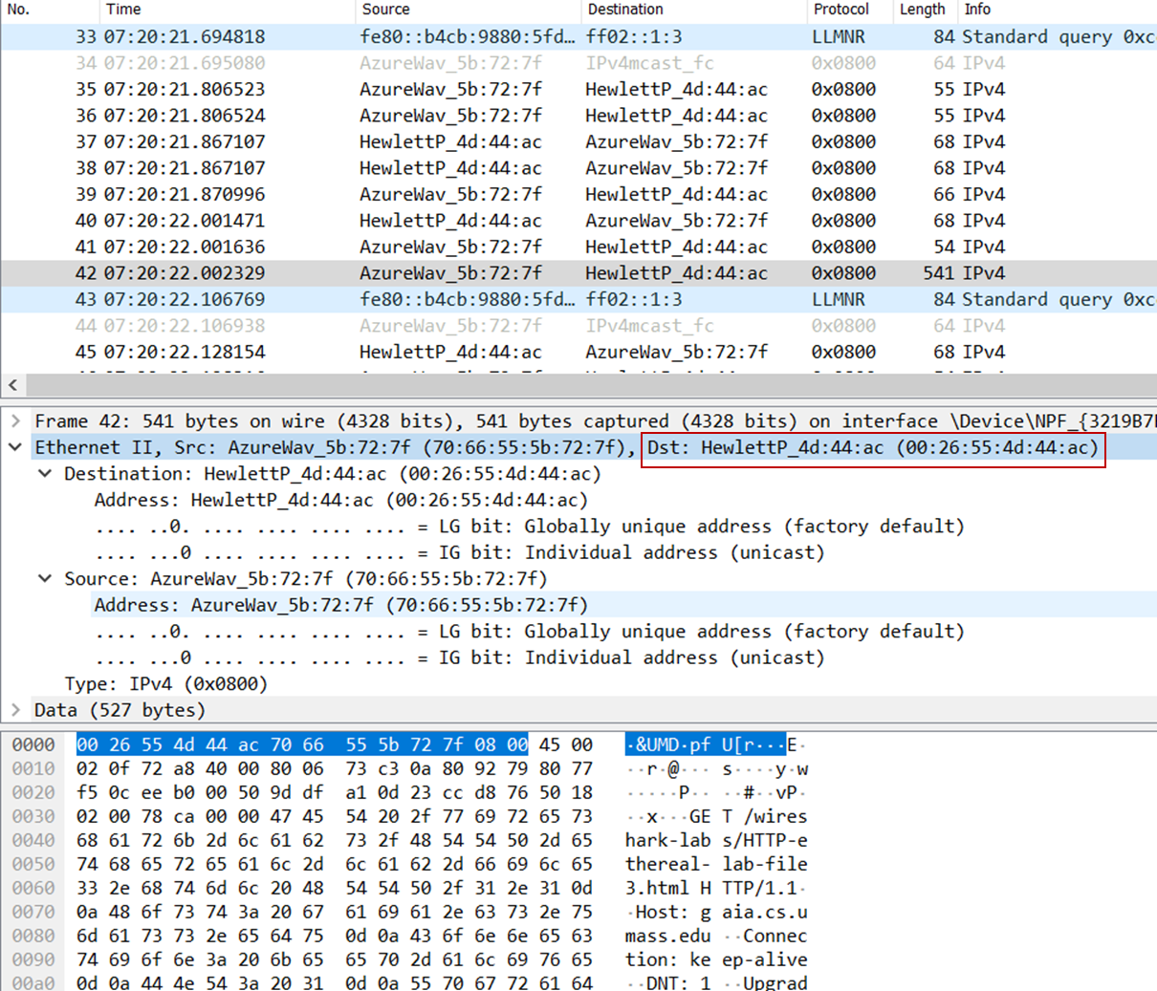

***3/ Give the hexadecimal value for the two-byte Frame type field. What upper layer protocol does this correspond to?***

Answer: The hexadecimal value for the two-byte frame type field is 0x0800. This corresponds to the IP protocol (the frame type filed indicates that the nest layer above IP – the layer to which the payload of the Ethernet frame will connect to IP.

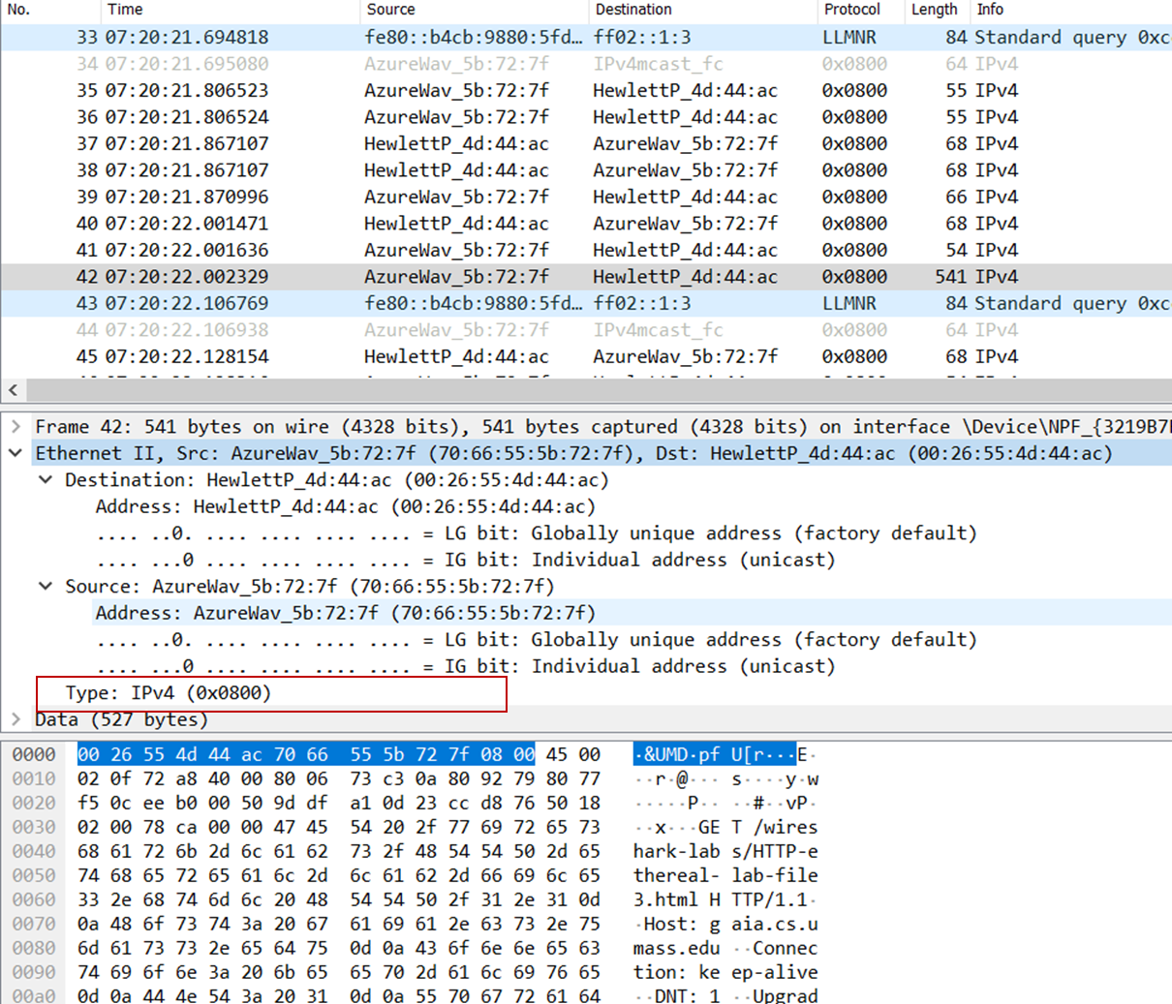

***4/ How many bytes from the very start of the Ethernet frame does the ASCII “G” in “GET” appear in the Ethernet frame?***

Answer: The ASCII “G” appears 54 bytes from the start of the Ethernet frame.

- The ethernet frame (first 14 bytes containing destination address, source address, and frame type)

- The IP header (20 bytes)

- The TCP header (20 bytes)

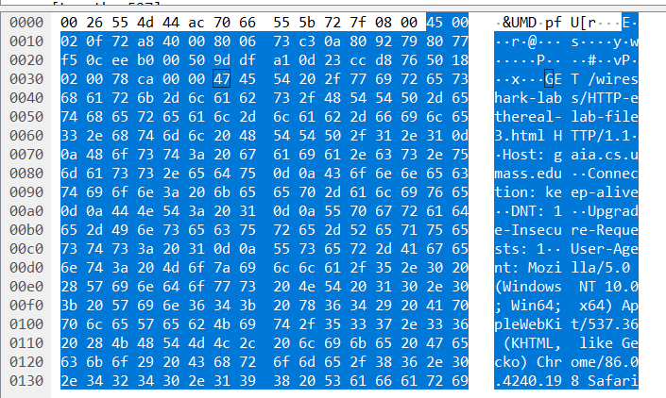

***5/ What is the value of the Ethernet source address? Is this the address of your computer, or of gaia.cs.umass.edu (Hint: the answer is no). What device has this as its Ethernet address?***

Answer: The value of the Ethernet source address is 00:26:55:4d:44:ac, this is not the address of my computer or gaia.cs.umass.edu. This is once again the address of the router that has recieved the ok message and forwarded it to my computer.

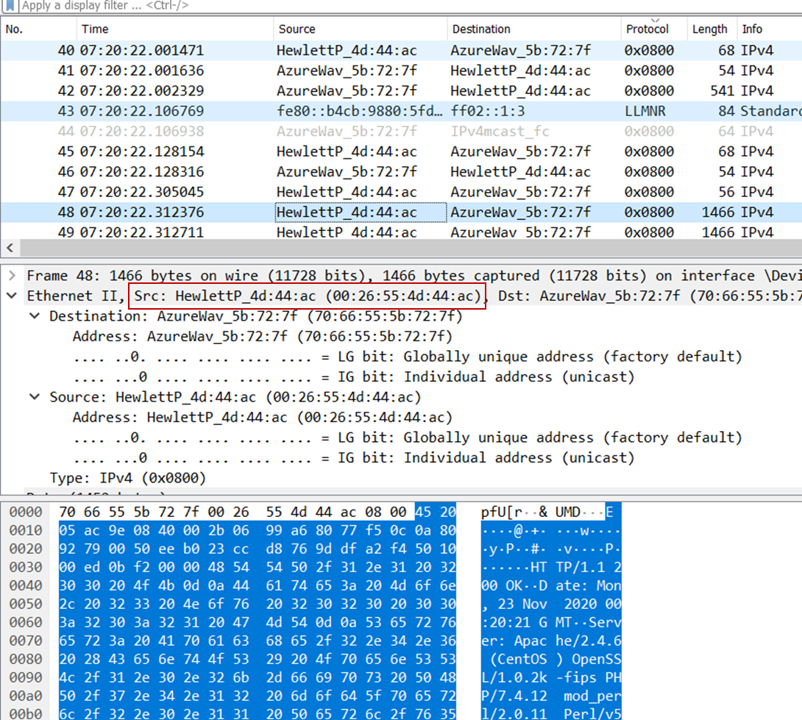

***6/ What is the destination address in the Ethernet frame? Is this the Ethernet address of your computer?***

Answer: The destination address is 70:66:55:5b:72:7f. This is the address This is the address of my computer.

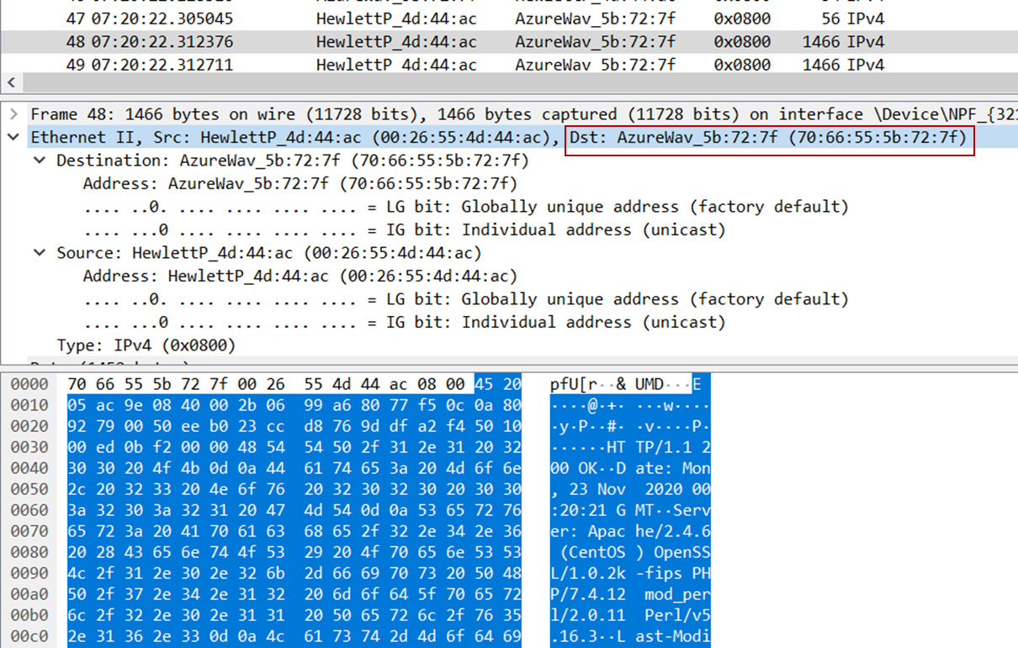

***7/ Give the hexadecimal value for the two-byte Frame type field. What upper layer protocol does this correspond to?***

Answer: The hex value of this field is 0x0800. This corresponds to the IP protocol.

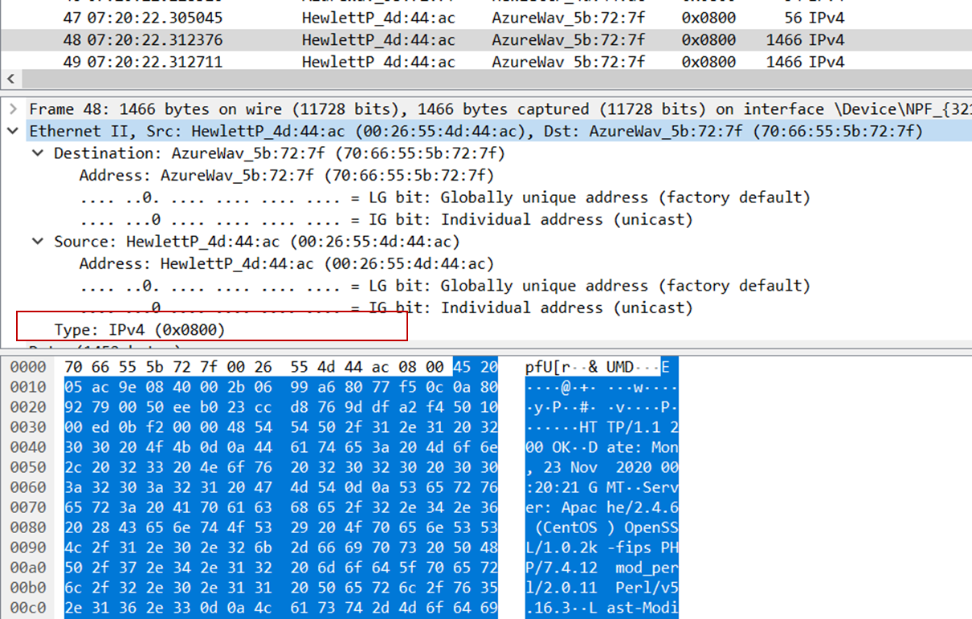

***8/ How many bytes from the very start of the Ethernet frame does the ASCII “O” in “OK” (i.e., the HTTP response code) appear in the Ethernet frame?***

Answer: There are 67 bytes before the “O” (or “O” appears as the 68th byte). These bytes include the ethernet frame, the IP header, the TCP header, and some HTTP preamble text.

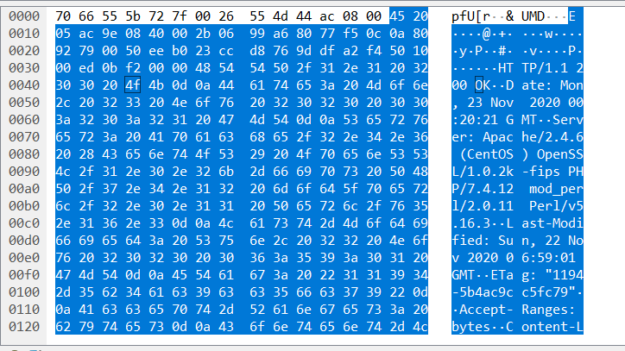

***9/ Write down the contents of your computer’s ARP cache. What is the meaning of each column value?***

Answer: The columns show the internet address (IPv4) and the physical address (Ethernet). The last column shows whether the IPv4 address is dynamic or static.

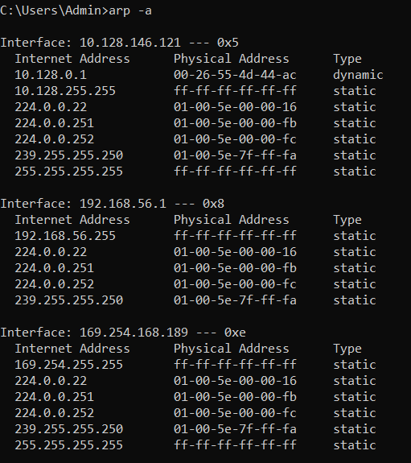

***10/ What are the hexadecimal values for the source and destination addresses in the Ethernet frame containing the ARP request message?***

Answer: The source address is (70:66:55:5b:72:7f), the destination address is (ff:ff:ff:ff:ff:ff). The source address is the Ethernet address of my computer and the destination address is broadcast.

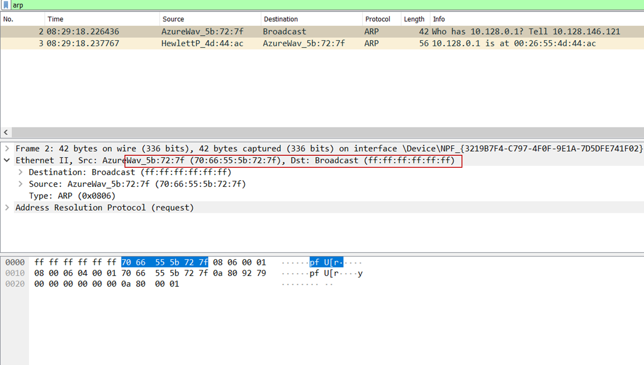

***11/ Give the hexadecimal value for the two-byte Ethernet Frame type field. What upper layer protocol does this correspond to?***

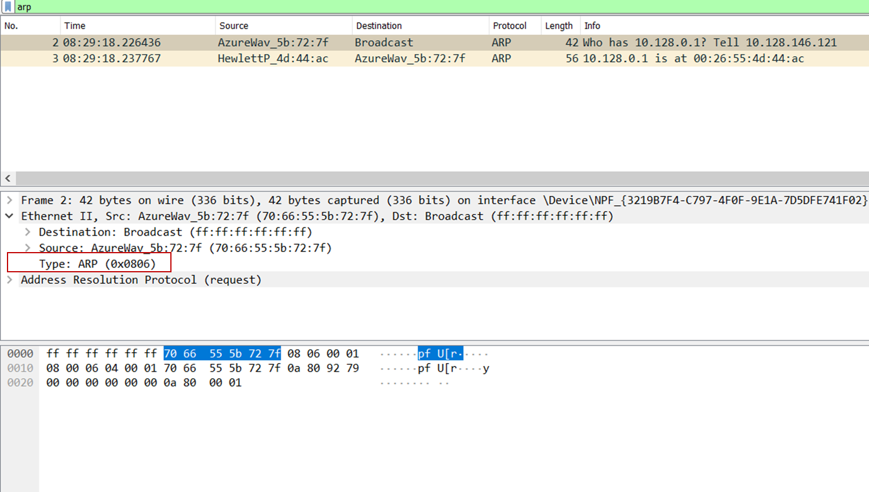Answer: The type value is 0x0806 which corresponds to ARP.

12/

***a/ How many bytes from the very beginning of the Ethernet frame does the ARP opcode field begin?***

Answer: The opcode field starts 20 bytes from the beginning of the frame.

***b/ What is the value of the opcode field within the ARP-payload part of the Ethernet frame in which an ARP request is made?***

Answer: The opcode has a hex value of 0x0001, which is for request.

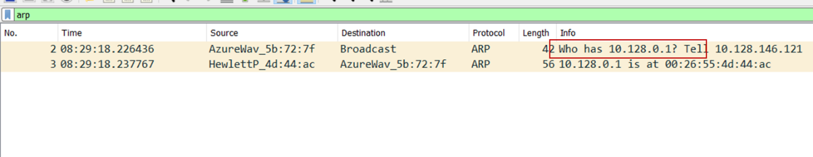***c/ Does the ARP message contain the IP address of the sender?***

Answer: The ARP message contains the IP address 10.128.0.1

***d/ Where in the ARP request does the “question” appear – the Ethernet address of the machine whose corresponding IP address is being queried?***

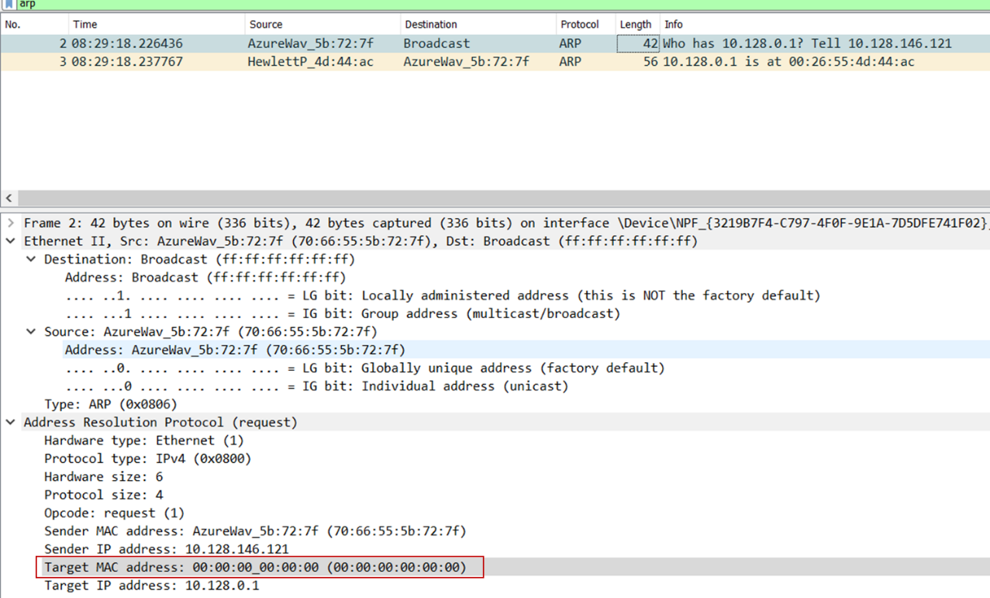Answer: The "question" is in the field Target MAC address, which is set to :00:00:00:00:00

13/

***a/ How many bytes from the very beginning of the Ethernet frame does the ARP opcode field begin?***

Answer: The opcode field begins 20 bytes from the beginning of the frame.

***b/ What is the value of the opcode field within the ARP-payload part of the Ethernet frame in which an ARP response is made?***

Answer: The hex value for opcode field withing the ARP-payload of the request is 0x0002, for reply message.

***c/ Where in the ARP message does the “answer” to the earlier ARP request appear – the IP address of the machine having the Ethernet address whose corresponding IP address is being queried?***

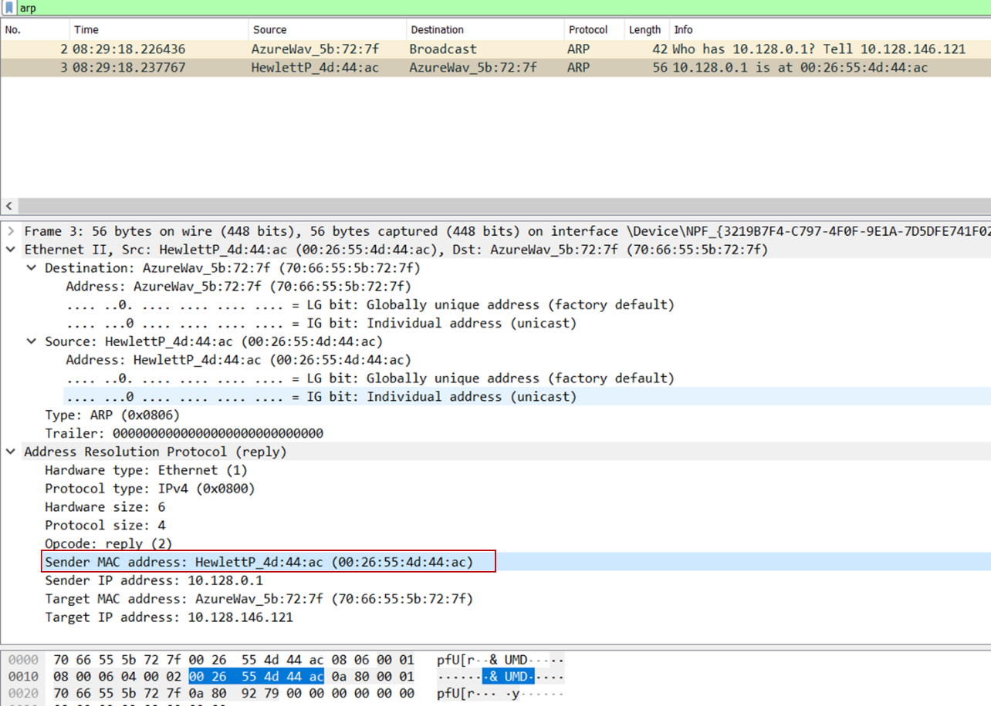Answer: The answer to the earlier ARP request appears in the “Sender MAC address” field, which contains the Ethernet address 00:26:55:4d:dd:ac for the sender with IP address 10.128.0.1

***14/ What are the hexadecimal values for the source and destination addresses in the Ethernet frame containing the ARP reply message?***

Answer: The source is (00:26:55:4d:44:ac), Destination (70:66:55:5b:72:7f)

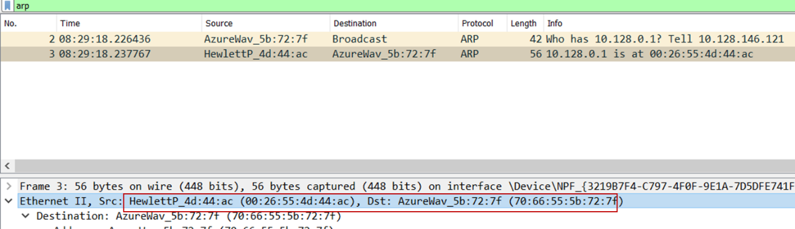

15/

Answer: There is no reply in this trace, because we are not at the machine that sent the request. The ARP request is broadcast, but the ARP reply is sent back directly to the sender’s Ethernet address.